
ST ANDREW’S JUNIOR COLLEGE
Preliminary Examinations
Higher 1

Geography 8834/01
Paper 1 31 August 2026
INSERT 3 hours

READ THESE INSTRUCTIONS FIRST

This insert contains all the Resources referred to in the questions.

This document consists of 9 printed pages.

[Turn over

Resource 1 for Question 1

Location and characteristics of the three fieldwork sites

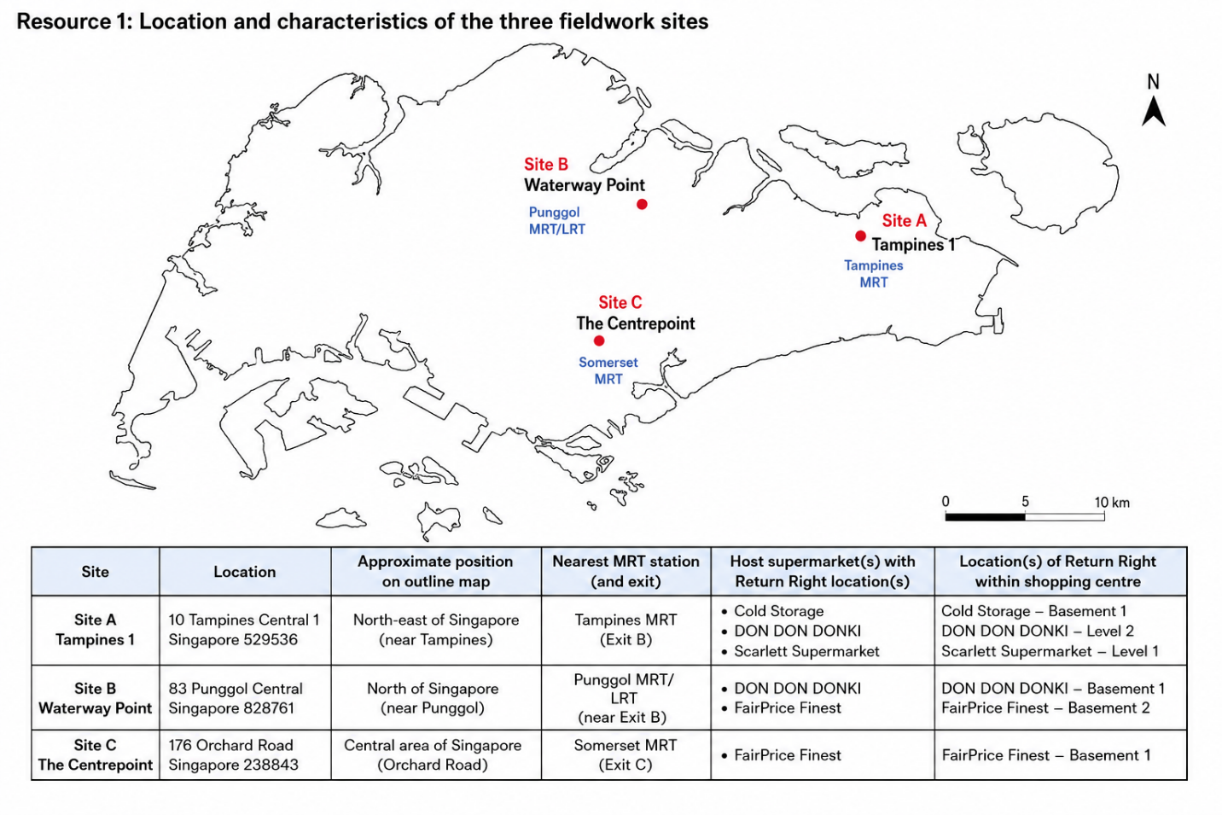

Resource 2 for Question 1

Examples of reverse vending machines in Singapore

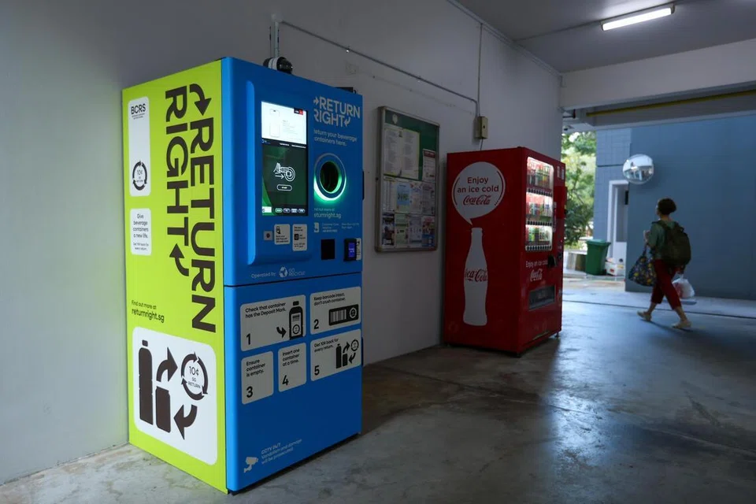 | 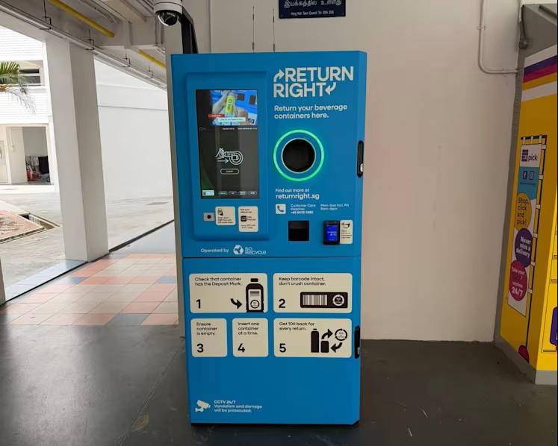

Resource 3 for Question 1

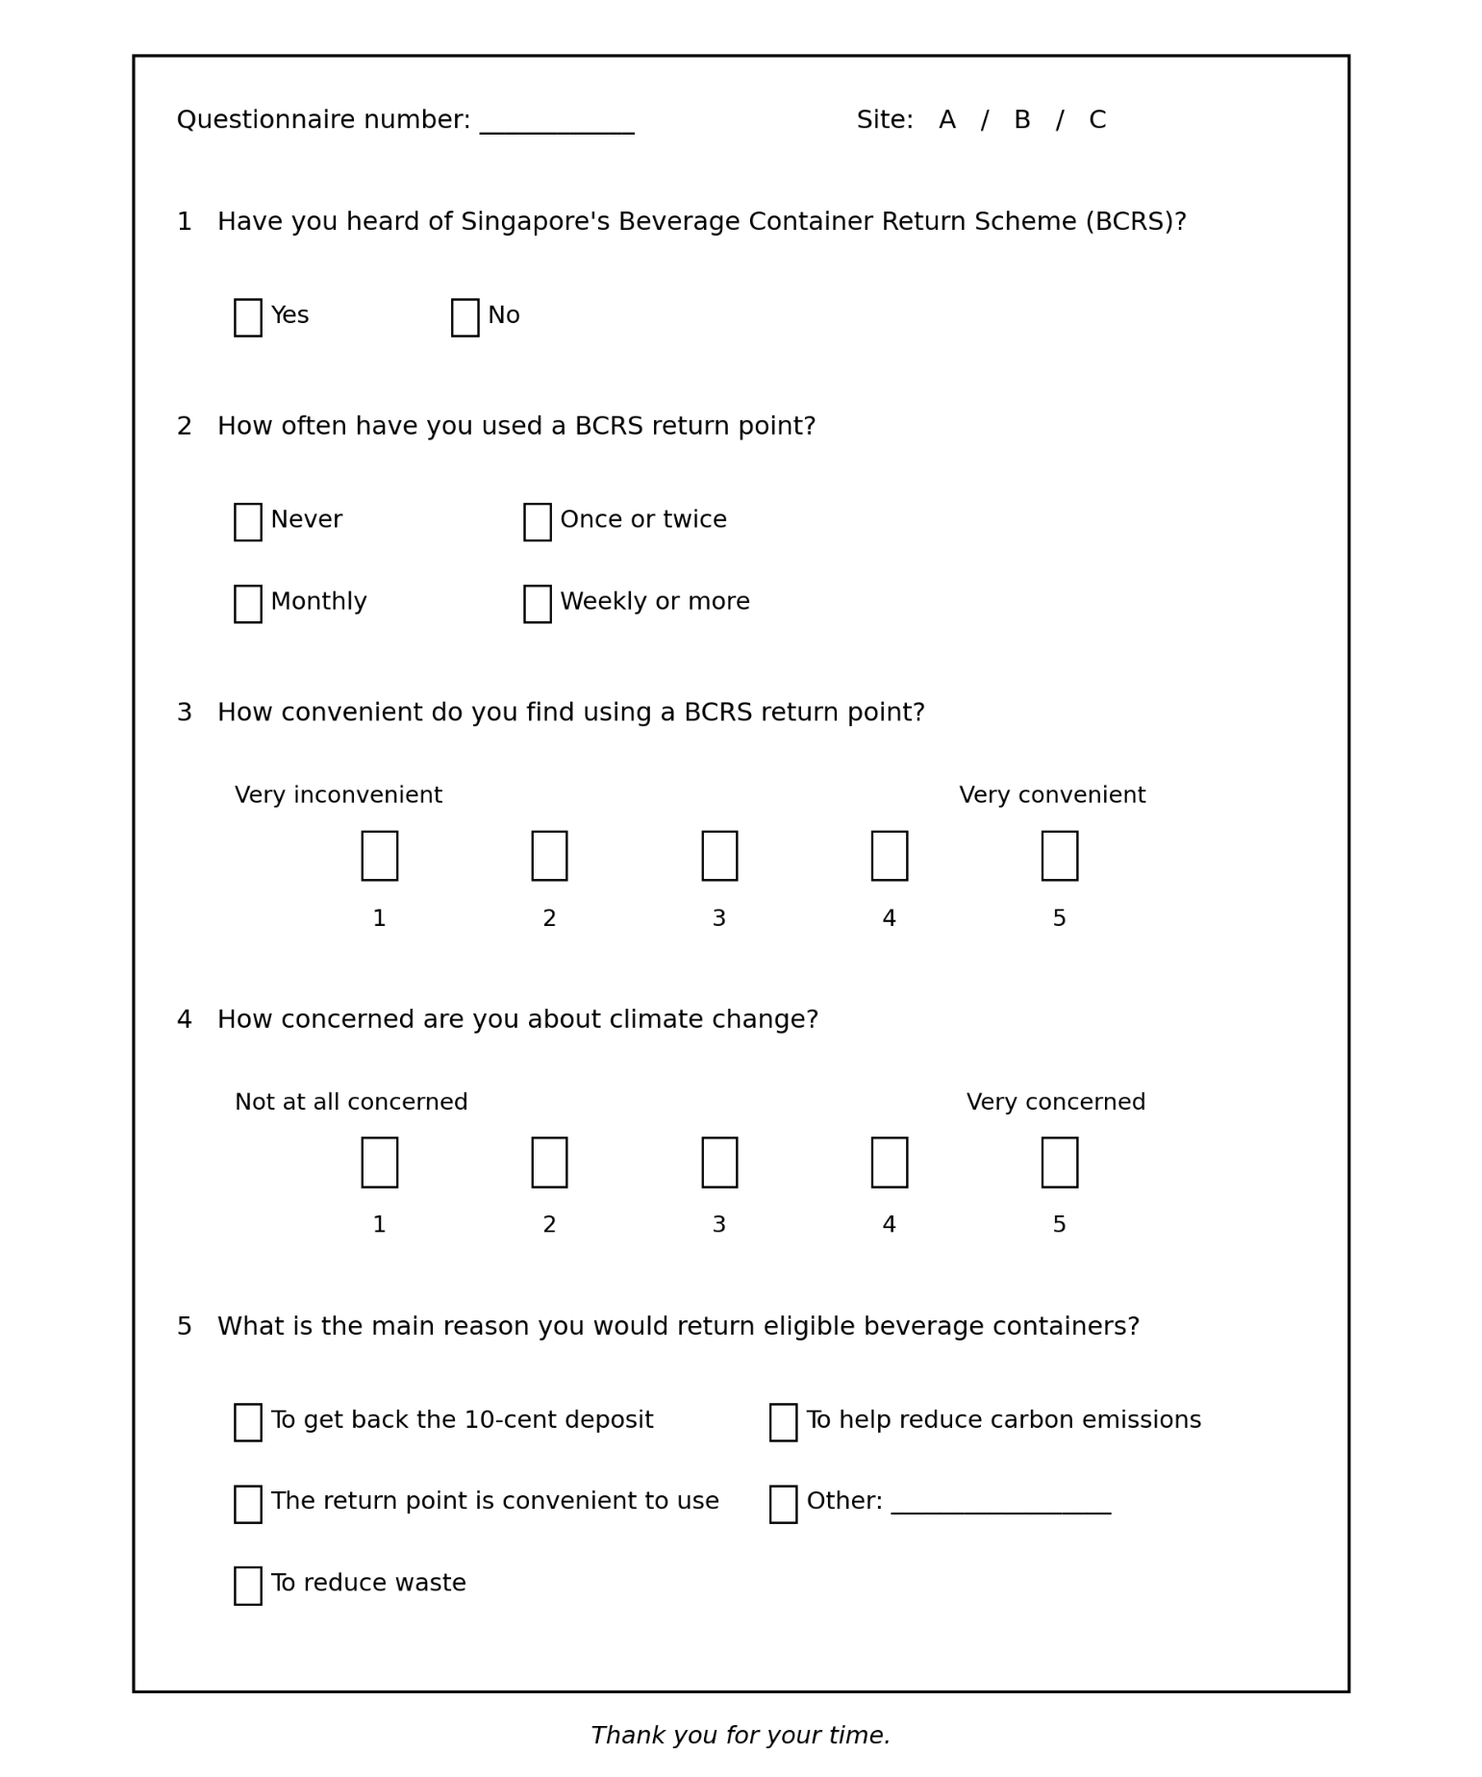
Questionnaire
5 What would be your main reason for returning eligible beverage containers?

[Turn over

Resource 4 for Question 1

Results of the investigation

Thirty respondents were surveyed at each site.
Site | Mean convenience score (1–5) | Mean climate concern score (1–5) | Respondents who had used BCRS at least once (%) | RVM users observed in 30 minutes
A | 4.4 | 3.8 | 73 | 24
B | 3.2 | 3.9 | 50 | 13
C | 2.1 | 3.7 | 27 | 6

Main reason given for returning eligible beverage containers
Main reason | Percentage of respondents (%)
To get back the 10-cent deposit | 34
Convenience of the return point | 31
To reduce waste | 20
To help reduce carbon emissions | 10
Other | 5
Note: Mean scores are based on the 1–5 scales shown in Resource 3.

Resource 5 for Question 2
A map of the Dharavi slum in Mumbai, India
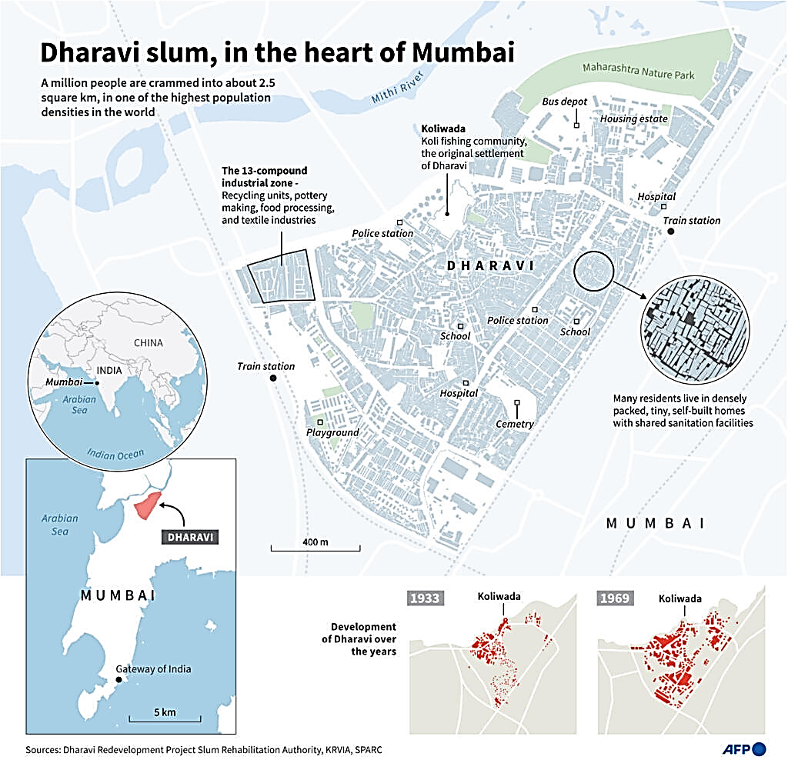

[Turn over

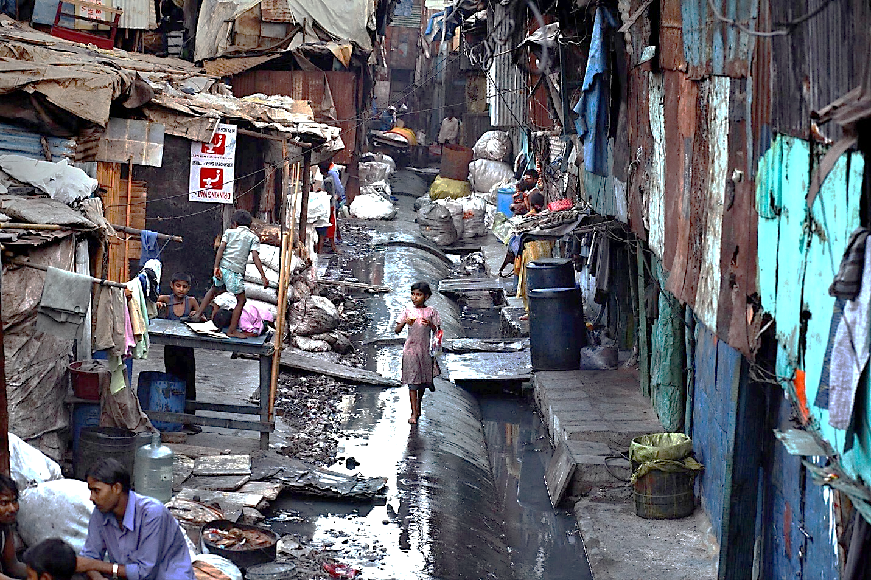

Resource 6 for Question 2
A photograph depicting the living conditions in Dharavi slum

Resource 7 for Question 2

Population and growth rate of Mumbai from 1901 to 2001
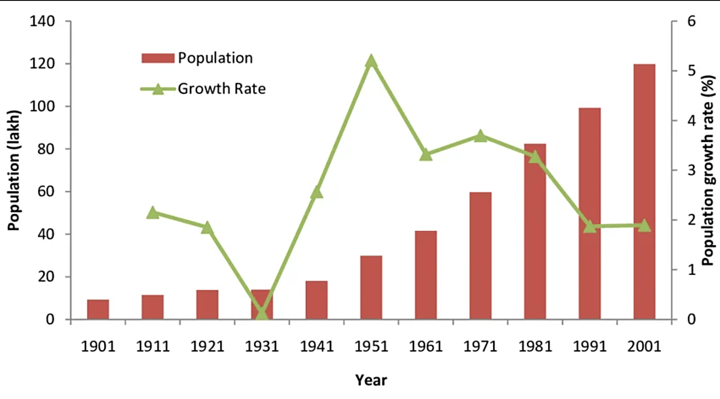

Resource 8 for Question 2

Article excerpt on slum expansion and housing policies in Mumbai, India

Mumbai is home to some of the world’s densest informal settlements, most notably Dharavi, where over 1,000,000 people live squeezed into just $2.39{\text{ km}}^{2}$— a population density exceeding 418,000 people per ${\text{km}}^{2}$. Across the wider city, slums cover roughly 24% of Mumbai’s total land area and house more than half its population.

Despite continuous government promises of a ‘slum-free Mumbai’, satellite data show encroached land grew by 68% between 2011 and 2025, with over 58 hectares of state land occupied since 2011 alone. To manage settlements, the state uses a tiered policy:

Pre-2000 structures | Eligible for free replacement housing
2000–2011 structures | Protected from eviction, but residents must pay for replacement housing
Post-2011 structures | Deemed strictly illegal and subject to demolition

Repeatedly pushing back legal cut-off dates (from 1995 to 2000, then 2011) has failed to stop new informal expansion into ecologically sensitive areas, including 8,000 ${\text{m}}^{2}$ of coastal mangroves and 18,800 ${\text{m}}^{2}$ along drainage channels.

While tools use quarterly satellite tracking to plan demolitions, officials admit that corrupt local politicians and powerful slumlords often work together to protect new settlements in exchange for money and votes. Furthermore, cleared land is rarely redeveloped into public spaces immediately, leading to rapid re-encroachment. Urban planners suggest moving away from free housing promises toward state-funded public rental housing.

[Turn over
Resource 9 for Question 3

Changes in temperature and atmospheric carbon dioxide concentration over the past 800 000 years

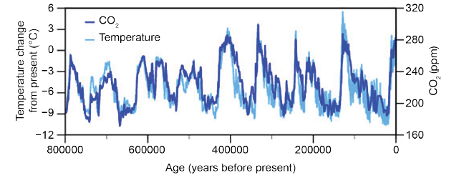

Resource 10 for Question 3

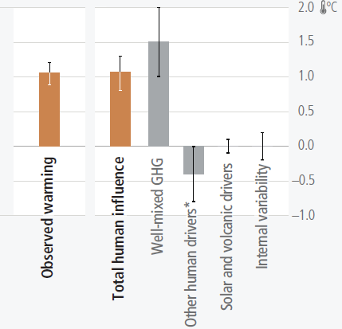
Contribution of human and natural factors to observed global warming
Temperature change attributed to total human influence (broken down into changes in GHG concentrations and other human drivers), solar and volcanic drivers, and internal climate variability
* Other human drivers are predominantly cooling aerosols, but also warming aerosols, land-use change (land-use reflectance) and ozone.

Resource 11 for Question 3

Projected global surface temperature change, 2081 to 2100

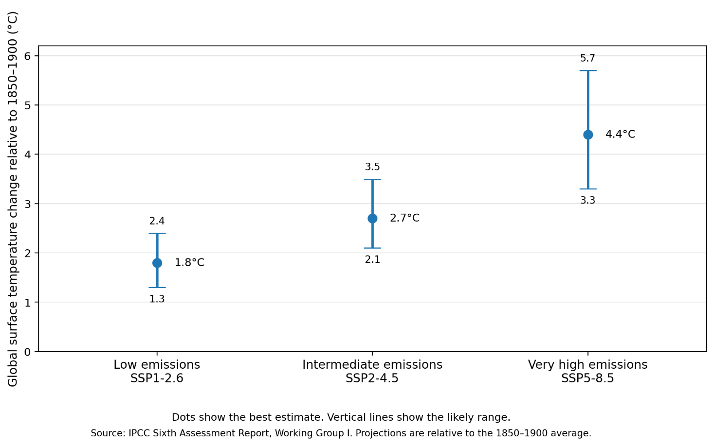
scenario
scenario
scenario

